Our Class Charter
We worked together and agreed a charter for a rights respecting classroom. The charter is based on the United Nations Convention on the Rights of the Child (UNCRC).

Newsletter
P5/6/7
Term 1
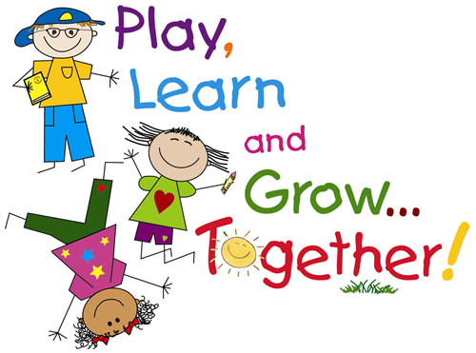
Timetable
Tuesday – French with Madame Coles
Wednesday – PE with Mr Strachan
Community Groups/Assembly
Thursday – Art with Mrs Cooper
Friday – PE with Mrs Burness

Dates for your Diary

Tuesday 30th August – Football training begins

Tuesday 13th September – Roald Dahl Day (dress up as your favourite Roald Dahl character or wear your party clothes)

Homework

Homework will be sent home on a Monday and is due in on a Friday. Homework will consist of a Literacy and Numeracy task, and there may be additional homework throughout the year e.g. Topic homework. Reading will also be sent home at least two times a week.

Please sign homework diaries to indicate that you have seen/heard the homework.

Maths

Our main focus for numeracy this term will be:

Angle, symmetry and transformation

We will start the term exploring types of angles such as right angles, acute angles and obtuse angles.

We will also be learning how to accurately measure and draw angles using appropriate equipment. We will look at what angles we can find in the environment and how to measure these angles appropriately, along with finding missing angles in 2D shapes.

Time
On Tuesday’s, we will explore the topic of Time with Miss Hampton. We will be:
- Exploring the 12 and 24 hour clocks
- Calculating durations of events/activities
- Working out start/finish times when given the opposite time and the duration of the event.
- Dates on the calendar and calculating durations in days/weeks/months.

Addition and Subtraction

P4 - It is really important that we keep practising our times tables.

Measurement

We will be learning about measurement when we are creating our Willy Wonka creations! The main focus will be capacity and weight.

Health and Well-being

Bullying

We will start this term exploring and understanding the definition of bullying. We will look into how to deal with bullying and how to help someone who is being bullied.

Healthy Eating

After we have looked at bullying, we will be moving onto learning about healthy foods. We will focus on the ratio of foods we should have on a daily basis, the amounts of sugar in foods and drinks, along with reflecting on our own eating habits.

Literacy

We will be learning how about grammar and how to use it correctly. We will start the term exploring punctuation and transferring what we are learning into our writing and other literacy activities.

Due to Roald Dahl’s 100th birthday being on Tuesday 13th September, we will be reading ‘The BFG’ as a class. We will be focusing on the conflict between the characters in the book, linking to our Topic. This will also be used as a stimulus for writing and developing/extending our understanding of texts.

In writing, we are focusing on functional writing, looking at the features of it and the styles we can use. We will be writing newspaper articles and reports to name a few. We will link our writing to the class topic, Conflicts around the World.

Topic

This term, we will be learning about ‘Conflicts around the World’, exploring wars from WW1 up to the most recent conflicts, such as The Syrian War.

We will be linking our topic to other curricular areas such as Expressive Arts and Literacy.

Religious Moral Education

This term, we will be learning about Buddhism. We will focus on the beliefs, symbols and how it is practiced in order to understand the religion. We will explore important artefacts, places, and figures to Buddhism, linking to Expressive Arts and Literacy.

We would like to remind everyone that R.M.E is about learning about other religions. There is no pressure to share/discuss our beliefs during these lessons.

Technologies

Technologies are connected strongly with all the other areas of the curriculum. We will be continuing to use Book Creator to record our learning. We will also be using Apps such as: iMovie and PowerPoint. We are very close to having an iPad each!

